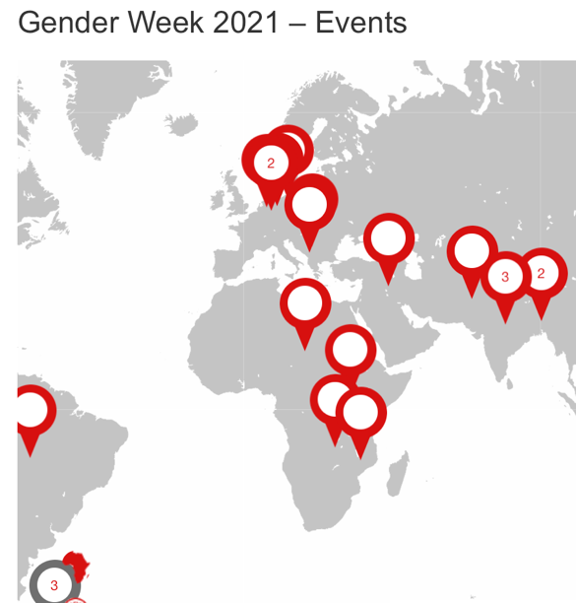 gender-works.GIZ.de

Topic | Day | Time | Link for more info and participation
International: “Towards a Gender-Equal World” – Official Opening of GIZ Gender Week 2021”  This year’s GIZ Gender Week will take stock of how we are dealing with the effects of the COVID-19 at present and how best we can safe-guard achievements made on gender equality against any deterioration and backlash | 8/3 | 15.00 – 16:30 CET  (16-17:30MZ) | public virtual event - participate on MS TEAMS
United Nations observance of International Women’s Day 2021  UN Women is pleased to invite you to the United Nations observance of International Women’s Day 2021. The theme is “Women in leadership: Achieving an equal future in a COVID-19 world on the way to the Generation Equality Forum”. | 8/3 | 16:00 CET  (17:00 MZ)  10:00  UTC-05:00 | - UN Web TV  - Twitter  - Facebook  - YouTube
India: Striving for Generation Equality – What a short film has to do with women entrepreneurship promotion in India | 9/3 | 11:00-12:30 CET  (10-13:30MZ) | Contact Stephanie Mumenthaler to get the link to the online event
Moçambique: Apresentação do Gender Toolbox de ProEcon.  Gender Equality Toolbox For Inclusive Business Models and Development Partnerships with the private sector | 10/3 | 10-11 CET  (11-12 MZ time) | MS Teams
International: WBG Women, Business and the Law 2021 report and findings & German policy provisions and actions aimed at closing existing gender gaps | 10/3 | 15.00 - 16.30 CET | MS Teams Session.
Zambia: “Women Economic Empowerment – Best Practices from Zambia’s Agricultural Projects”  - You will be able to get deep insights into two of the following areas:  - ANALYZE: Value Chain Mapping: understand your target group  - ENCOURAGE: opportunity awareness: using radio programs and other ways  - EMPOWER: Financial Literacy Trainings: precondition for WEE  - ENABLE: advocacy: how a strong network helps to remove barriers  - MONITOR: robust indicators: using the ProWEAI (Women Empowerment in Agriculture Index) | 17/3 | 9-11 CET  (10-12 MZ) | Participation: WEE Best Practices from Zambia  More Info

